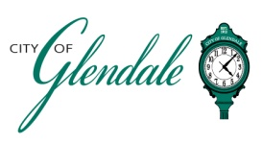
NOTICE OF MEETING
JUNE 10, 2026 – 6:00 PM
PLAN COMMISSION
TENTATIVE AGENDA

The Plan Commission meeting will immediately follow the Architectural Review Board Meeting

- MEETING CALLED TO ORDER

- ROLL CALL

- APPROVAL OF MINUTES FROM APRIL 8, 2026

- ZONING CODE UPDATE FINAL DRAFT DISCUSSION

- ADJOURNMENT

______________________________
Gabrielle Wesche
Community Engagement Officer

POSTED: _______________________, 2026

